# **IDLE’s Debugger**

* The *debugger* is a feature of IDLE that allows to execute program one line at a time. The debugger will run a single line of code and then wait to continue
* To enable IDLE’s debugger, click **Debug**▸**Debugger** in the interactive shell window.
* When the Debug Control window appears, select all four of the **Stack**, **Locals**, **Source**, and **Globals** checkboxes so that the window shows the full set of debug information

**How to Monitor values in a and b** : Debugging

Activate Debugger :: Shell Window - Debug Menu - Debugger

Check in Source, Globals

Select “Debugger” in shell window

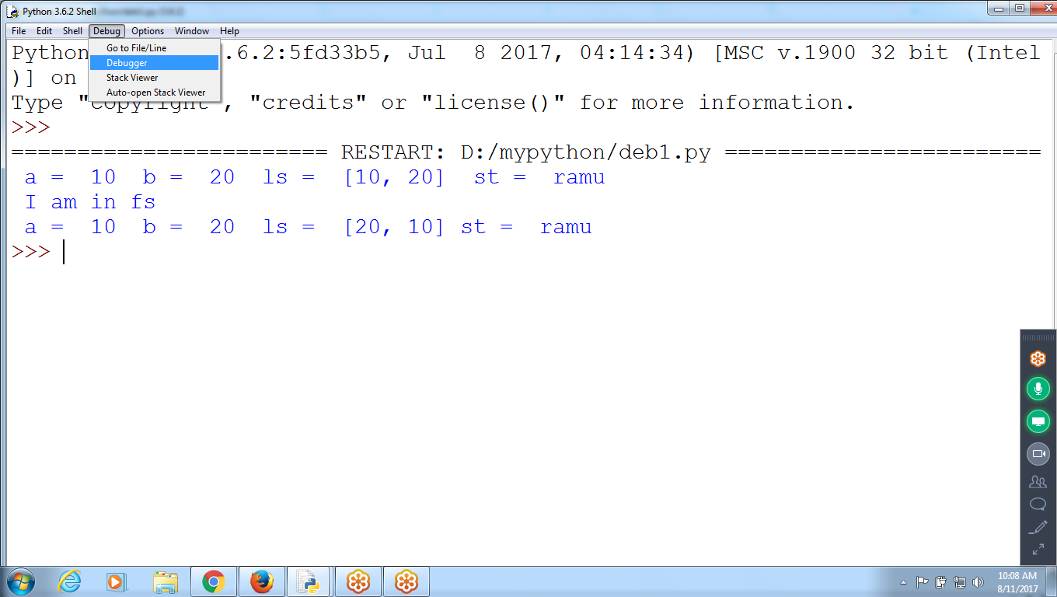

Click “F5” to execute

Select “Source” and “globals”

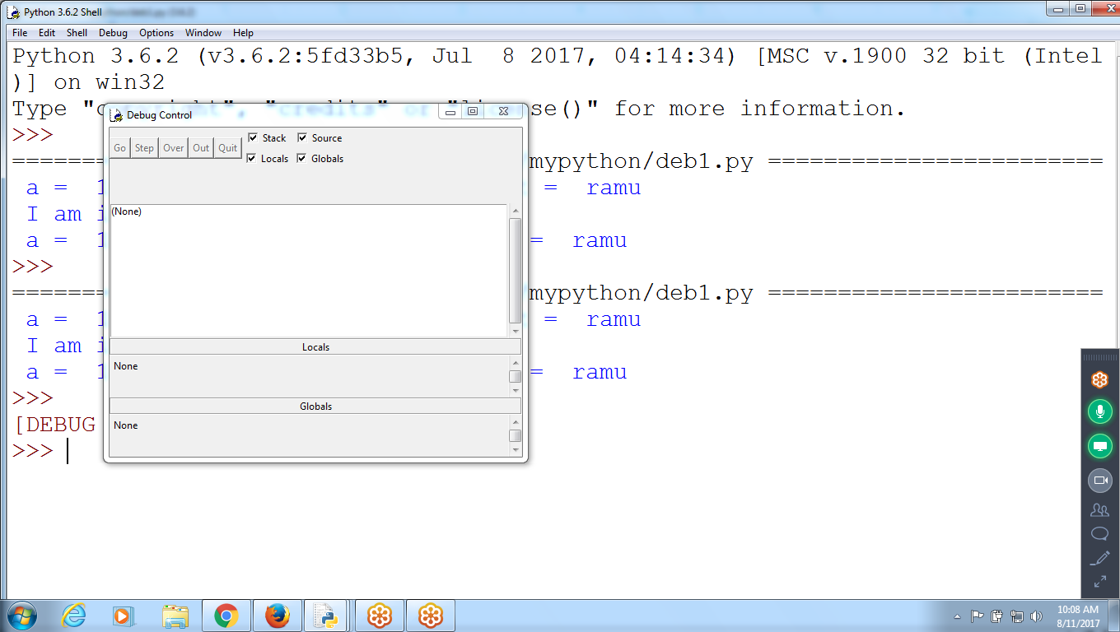

Click “F5” :: Debugging Starts as Debugger is ON

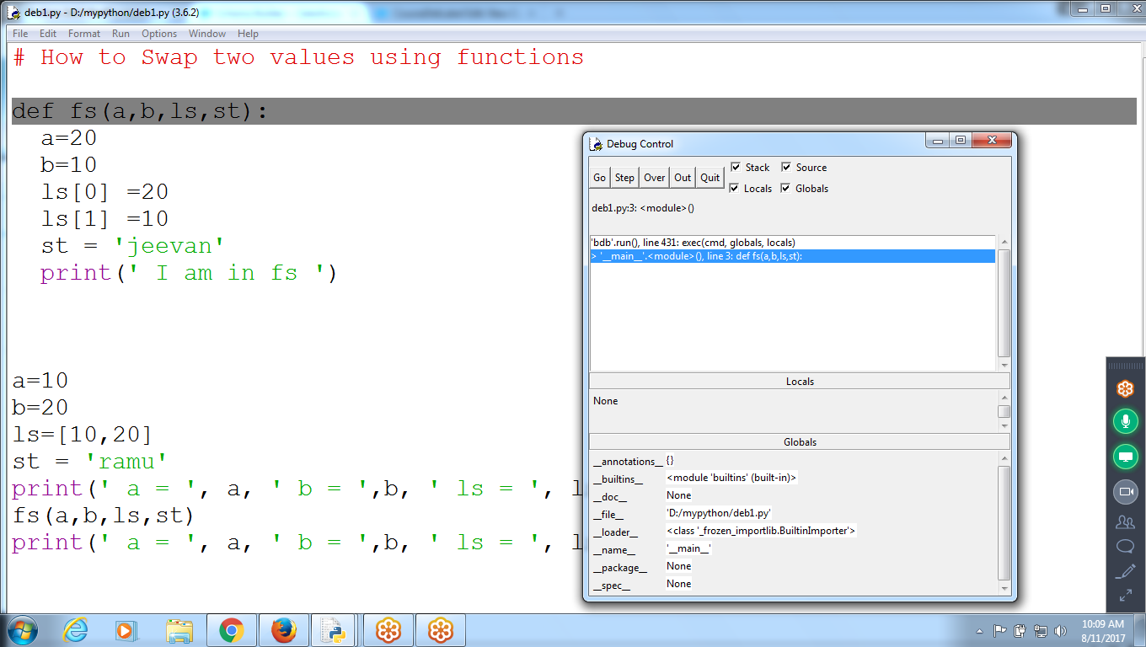

CLick GO, Step, Over, Out, Quit

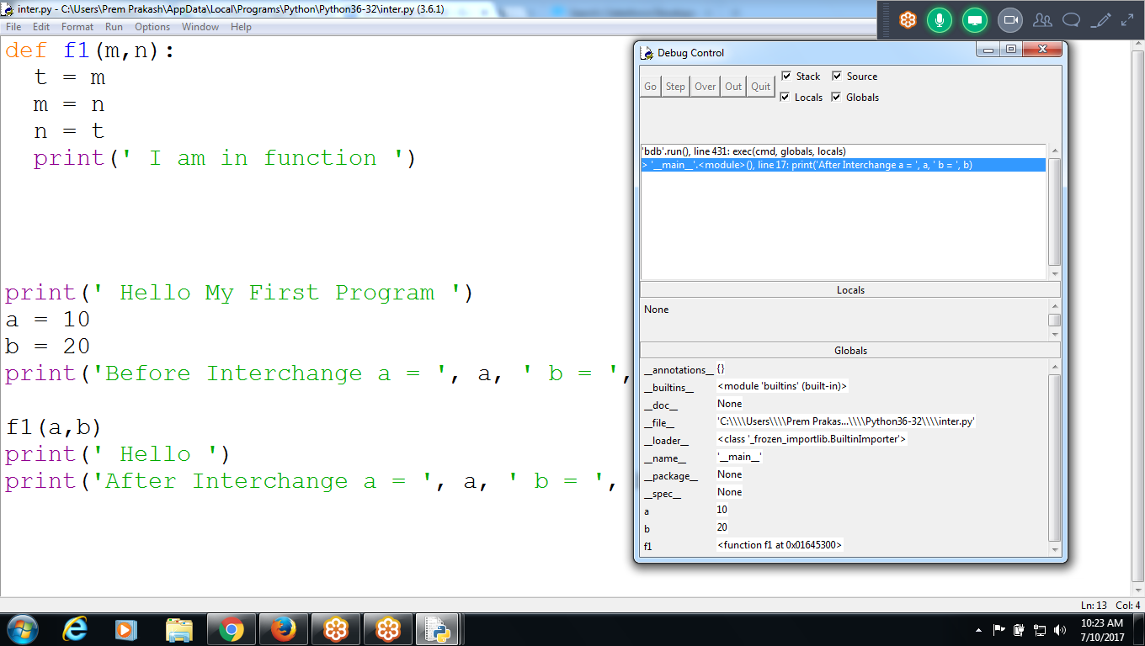

def f1(m,n):

t = m

m = n

n = t

print(' I am in function ')

print(' Hello My First Program ')

a = 10

b = 20

print('Before Interchange a = ', a, ' b = ', b)

f1(a,b)

print(' Hello ')

print('After Interchange a = ', a, ' b = ', b)

**Option 1 : GO** :: Normal Execution

Execute all the statements and shows the output in the shell

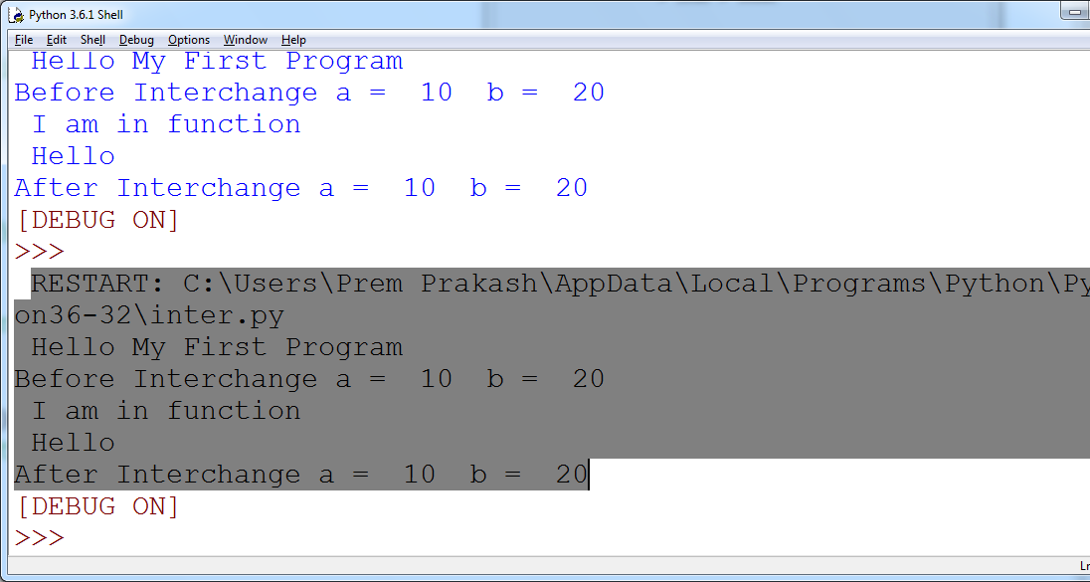

**Option 2: Step :: steps into the function**

Control is in **print(),** click “Step:

Result: Enters in standard Print() definition

When Control is in Standard Function “ Print”

Click “STEP” :: Enters into standard function definition

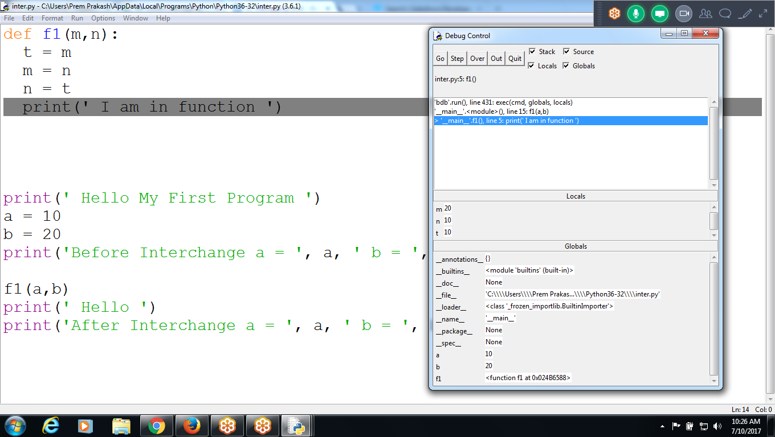

**Option 3 : Out :** To Come outside from the Existing Function

Inside “print” Definition,

to come out from inside definition, click “OUT”

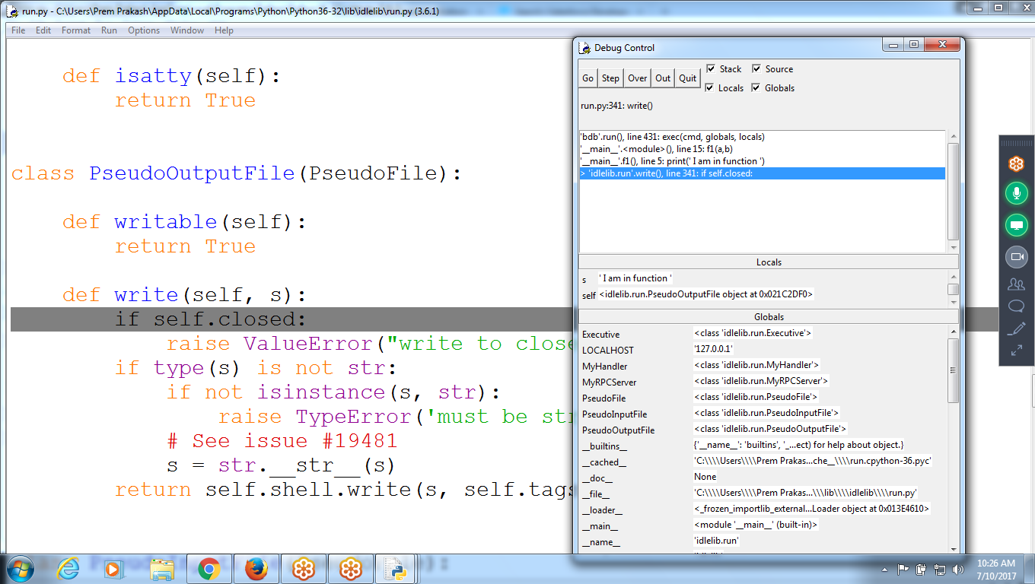

On selection of “OUT” control goes to next line “ Swap ()”

Come out from print()

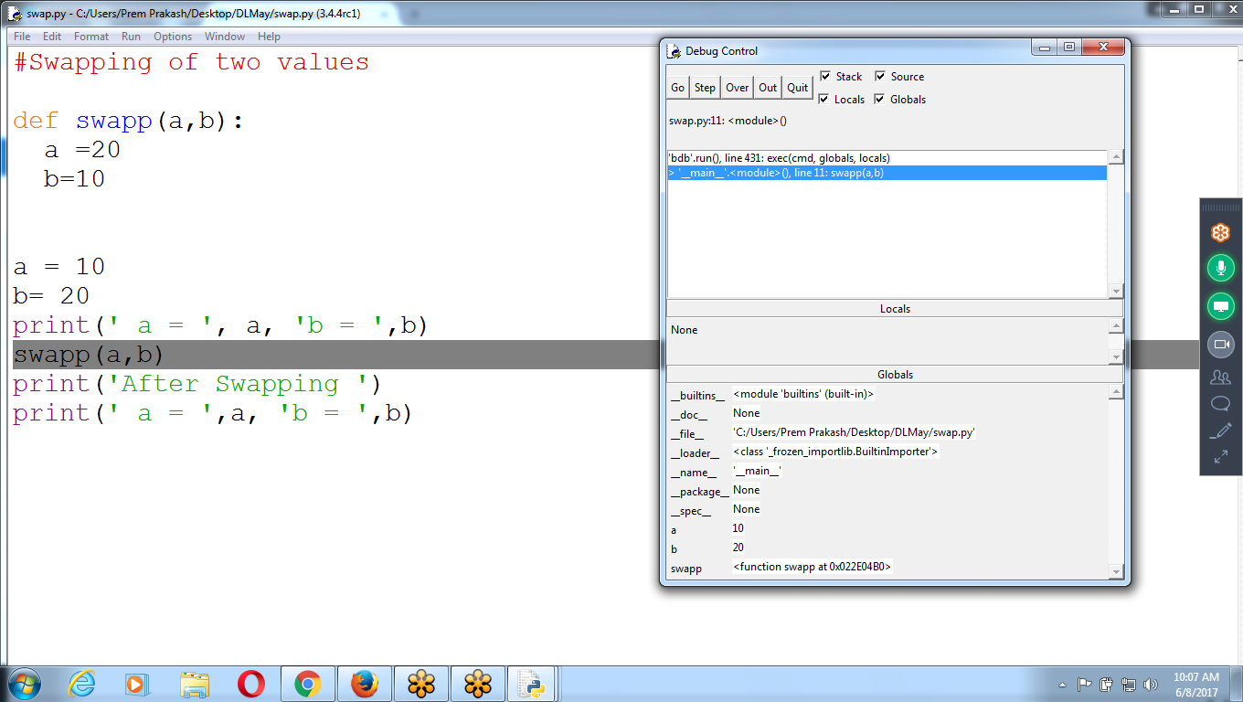

Option 1 : Go :: Normal

Option 2: step :: step into (Enters into the function (standard or Userdefined))

Option 3: Out: Come out of the function, but control in within the program

Option 4: “QUIT” ::Control moves out of the program

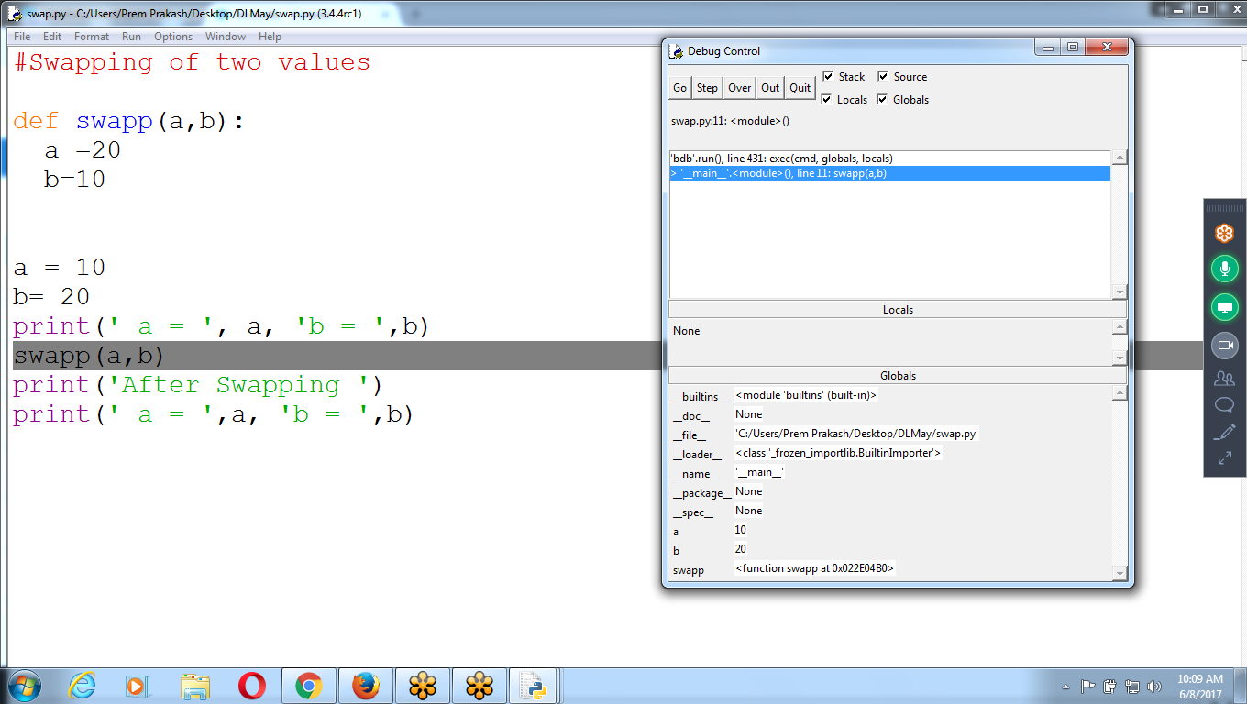

Control is in “Swap()”

Click “StEP” :: Enter into function

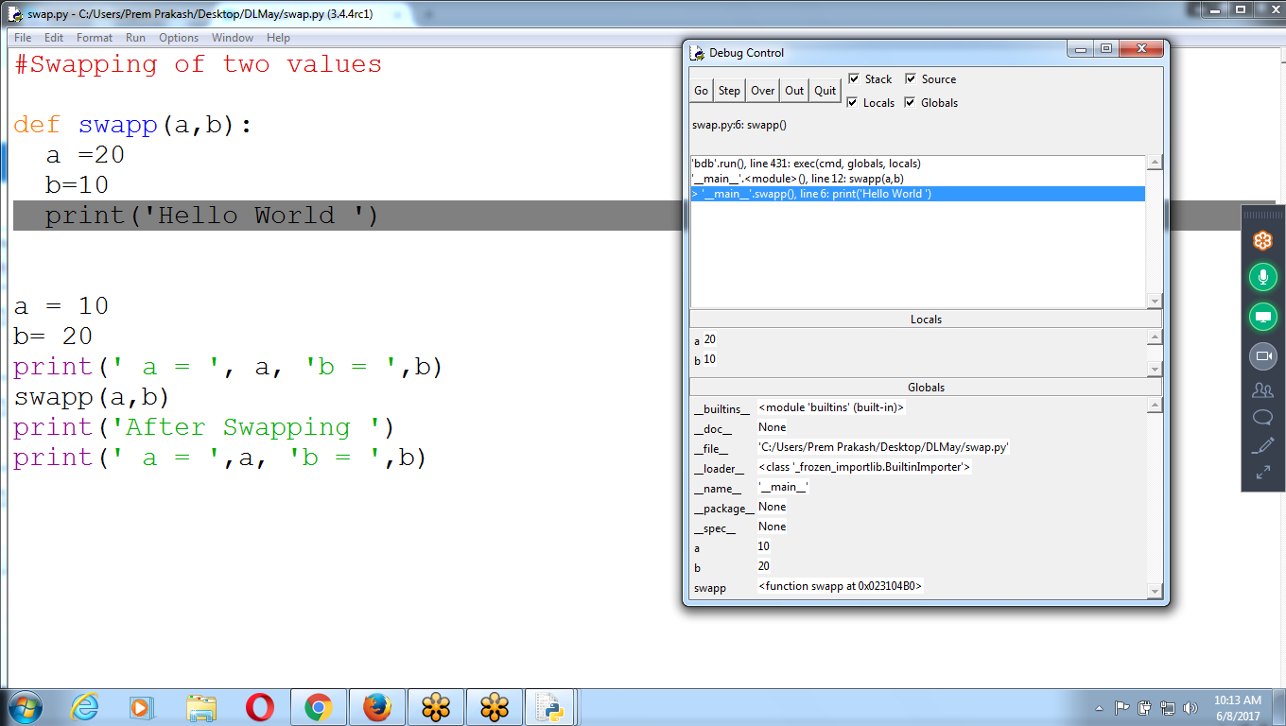

Global Variables : a,b are 10 and 20

Local Variables in SWAP (): a,b are 20 and 10

When Control is Out of the Function

Local Variables ERASED, only global variables Presents

REsult: Control is in Print() : Click “OVER”

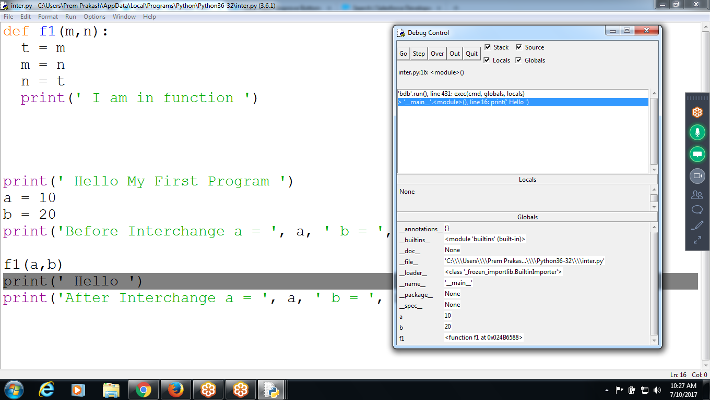

Result : Last Line : CLick “ OVER”

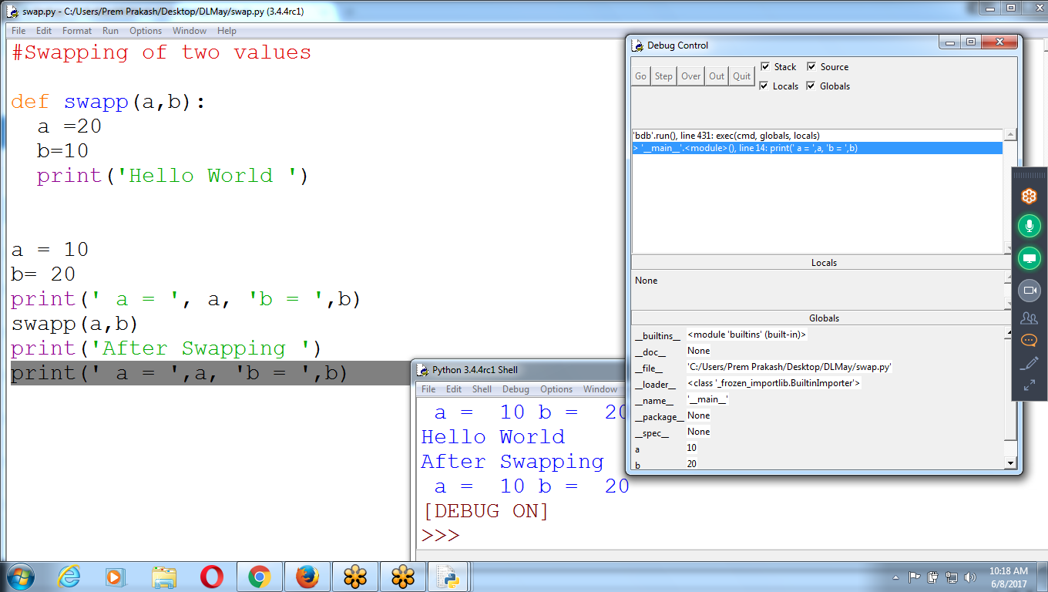

**Option 5: Quit :: Controls Moves out of Debugging**

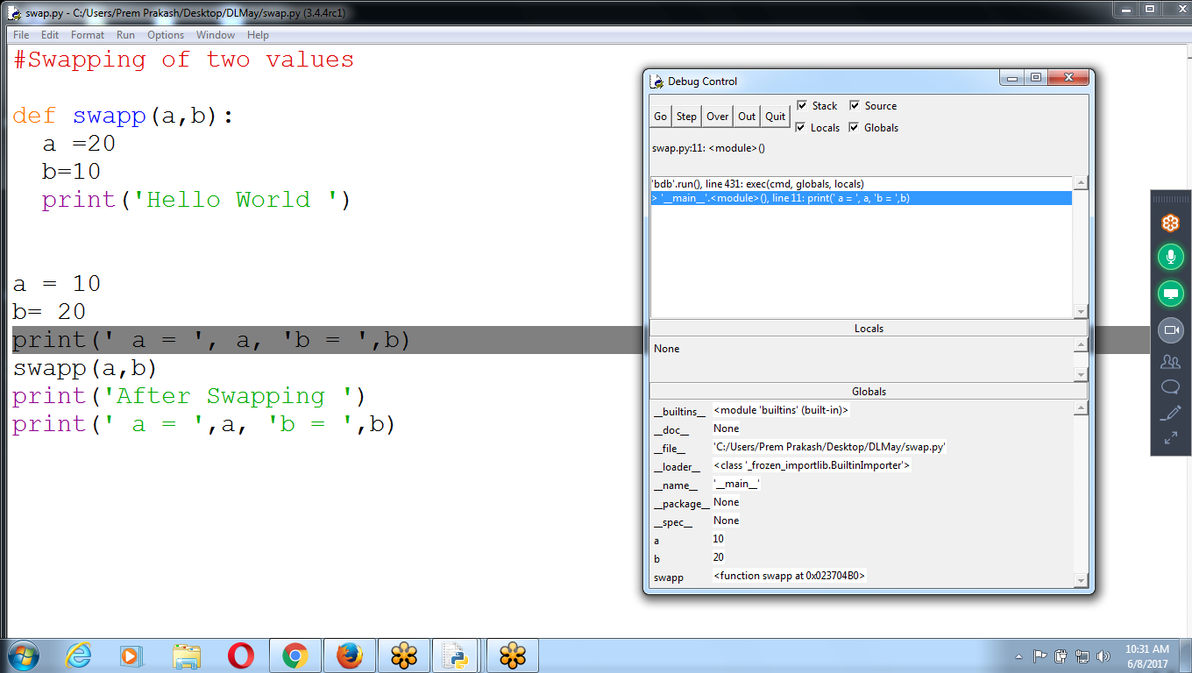

ON Selection of “QUit” : Debugging buttons Disabled

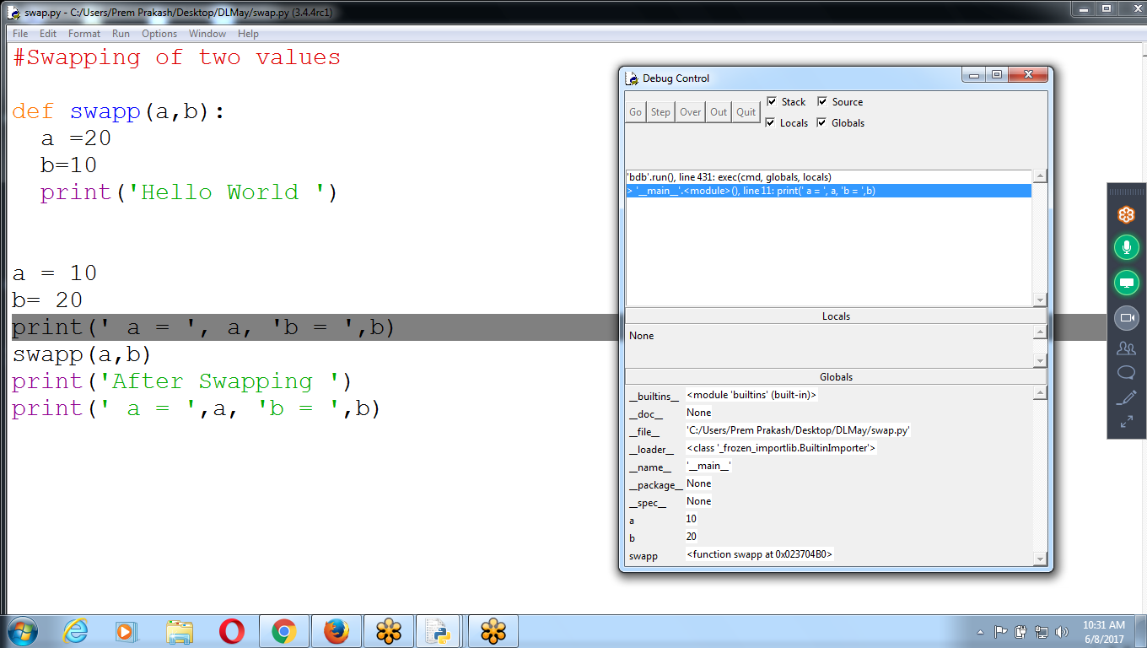

swap(a,b)

Values are changed in swap(), but it is not effecting in GLOBAL Variables

Passing Parameters (values) are called ::: **CALL By VALUE**

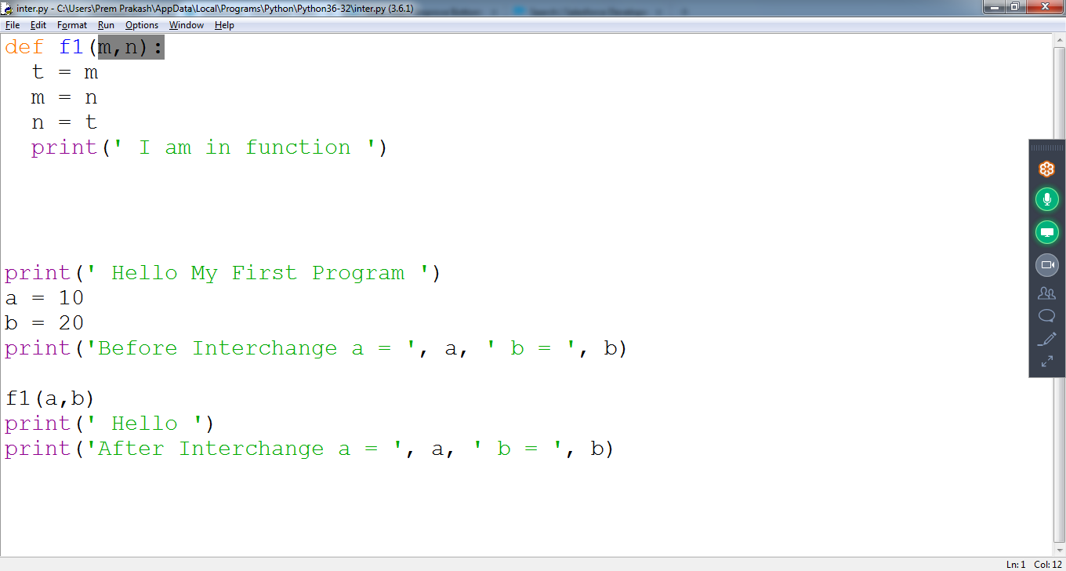

Immutable Objects:: Integer, string, tuple :: Can’t Modify the Structure

Mutable Objects ::Can Modify the values :: List

Same Example with LIST variable

Ls[0] contains ‘10’ and ls[1] contains ‘20’

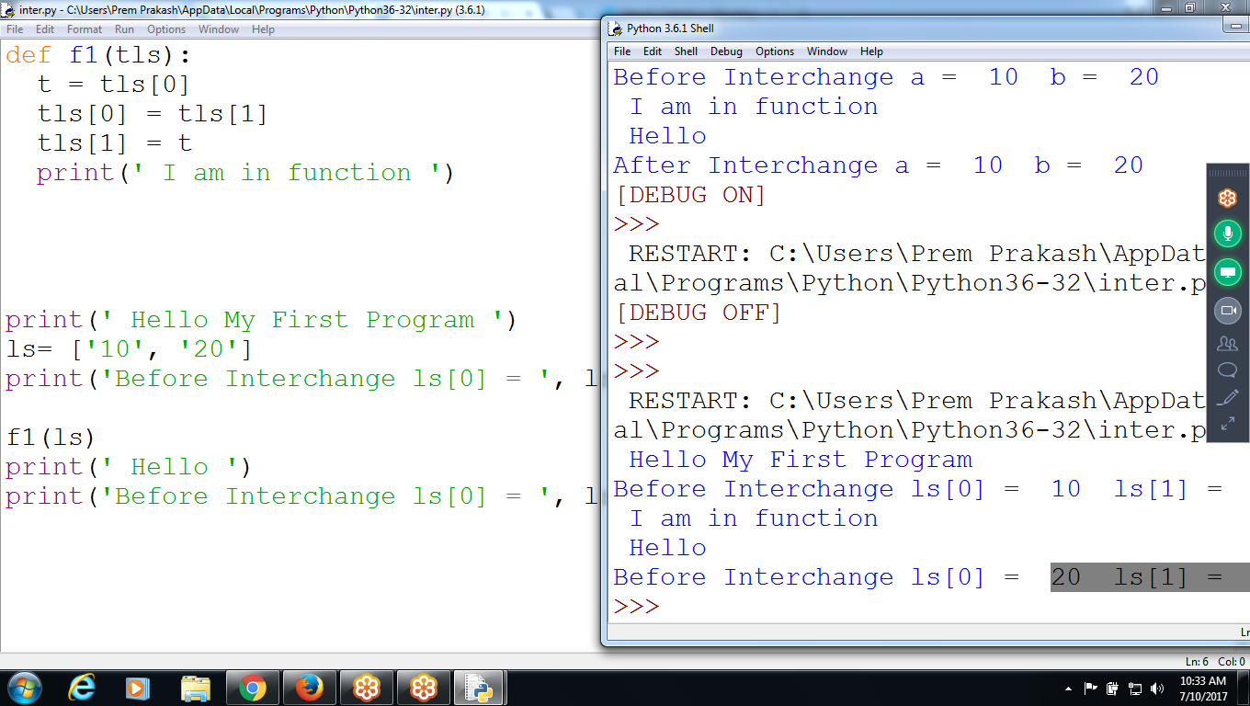

#Swapping of two values

def f1(tls):

t = tls[0]

tls[0] = tls[1]

tls[1] = t

print(' I am in function ')

print(' Hello My First Program ')

ls= ['10', '20']

print('Before Interchange ls[0] = ', ls[0], ' ls[1] = ', ls[1])

f1(ls)

print(' Hello ')

print('Before Interchange ls[0] = ', ls[0], ' ls[1] = ', ls[1])

Debugging::

Control is in ls of f1

Value changes in f1 effecting in f1 Global Variables :

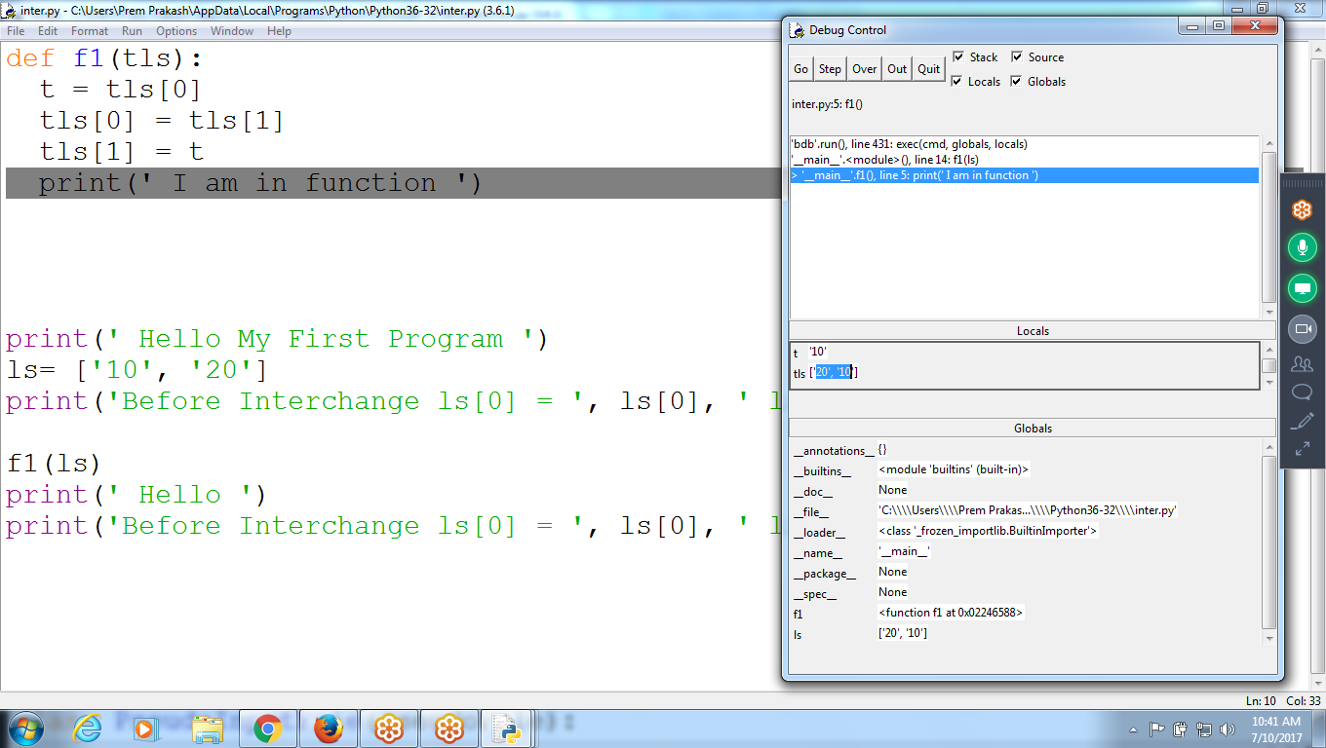

COntrol in Swap()

Values changed in swap() for LS variable, affecting in Global variables

ls[20,10 ] in local and Global

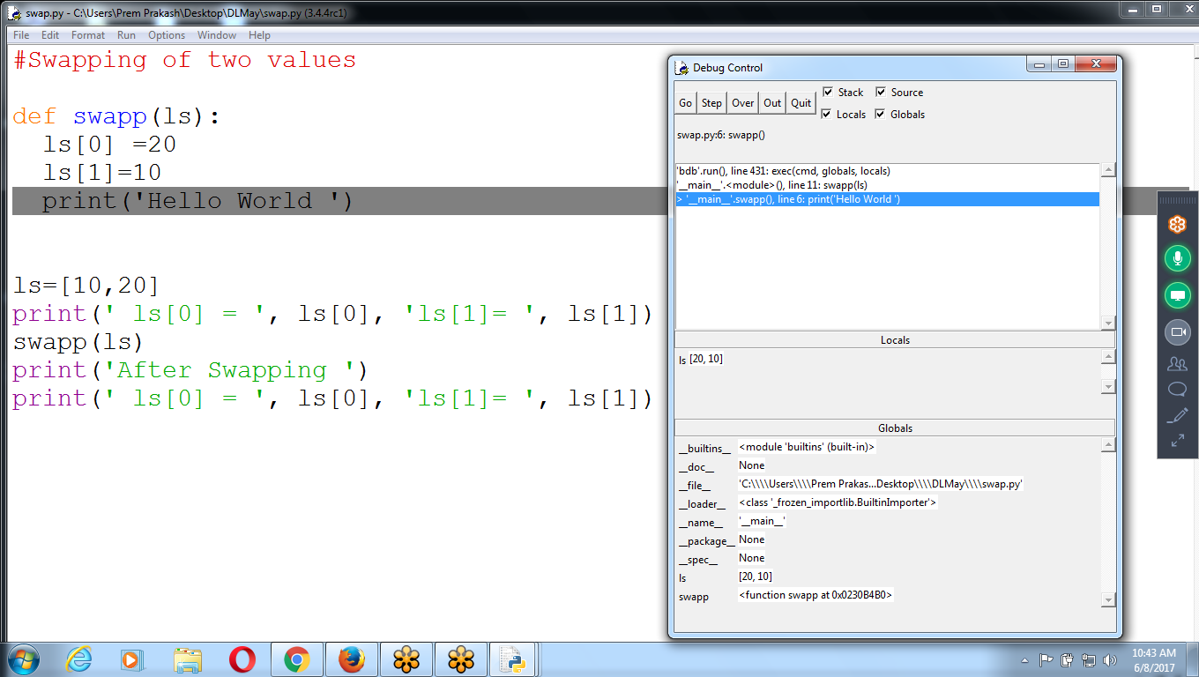

Example using :: Passing Integer, list, String and Tuple Parameters

LIST follows Mutable (can MODIFY)

INteger, string, tuple follows Immutable :: can not Modify

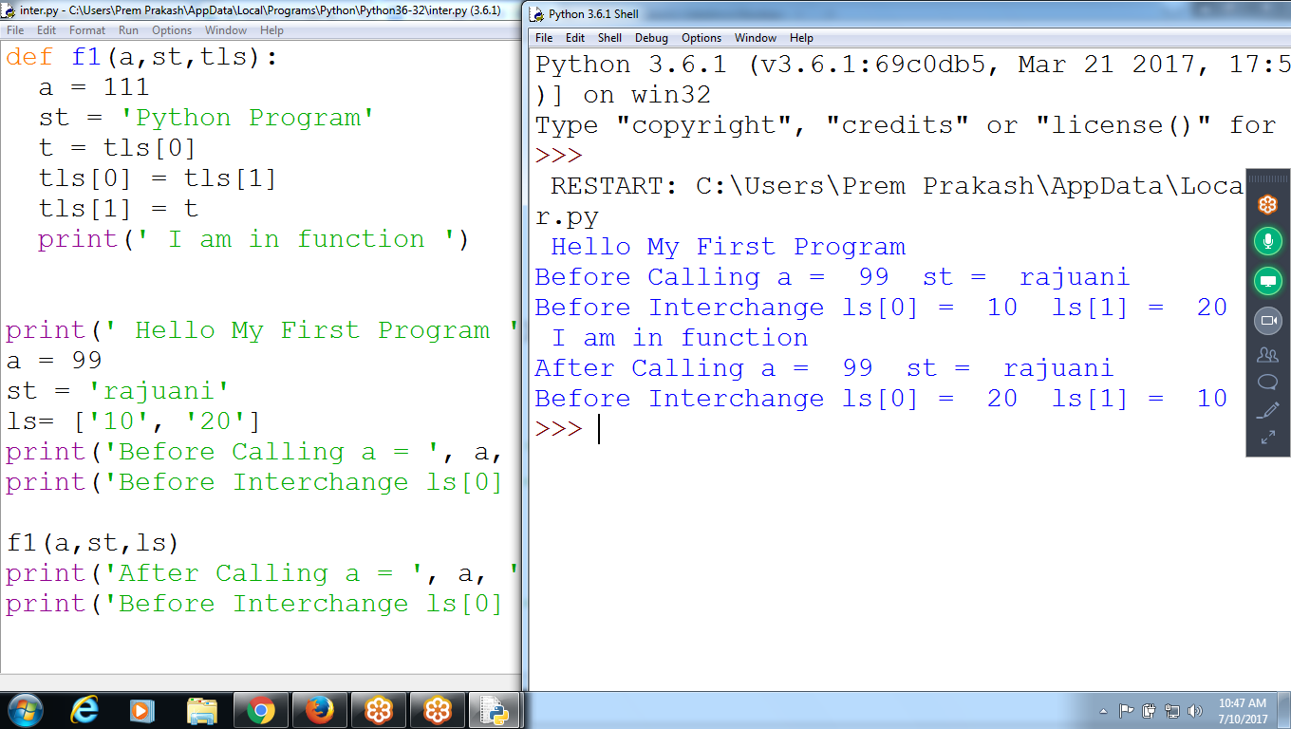

def f1(a,st,tls):

a = 111

st = 'Python Program'

t = tls[0]

tls[0] = tls[1]

tls[1] = t

print(' I am in function ')

print(' Hello My First Program ')

a = 99

st = 'rajuani'

ls= ['10', '20']

print('Before Calling a = ', a, ' st = ', st)

print('Before Interchange ls[0] = ', ls[0], ' ls[1] = ', ls[1])

f1(a,st,ls)

print('After Calling a = ', a, ' st = ', st)

print('Before Interchange ls[0] = ', ls[0], ' ls[1] = ', ls[1])

NOte:::

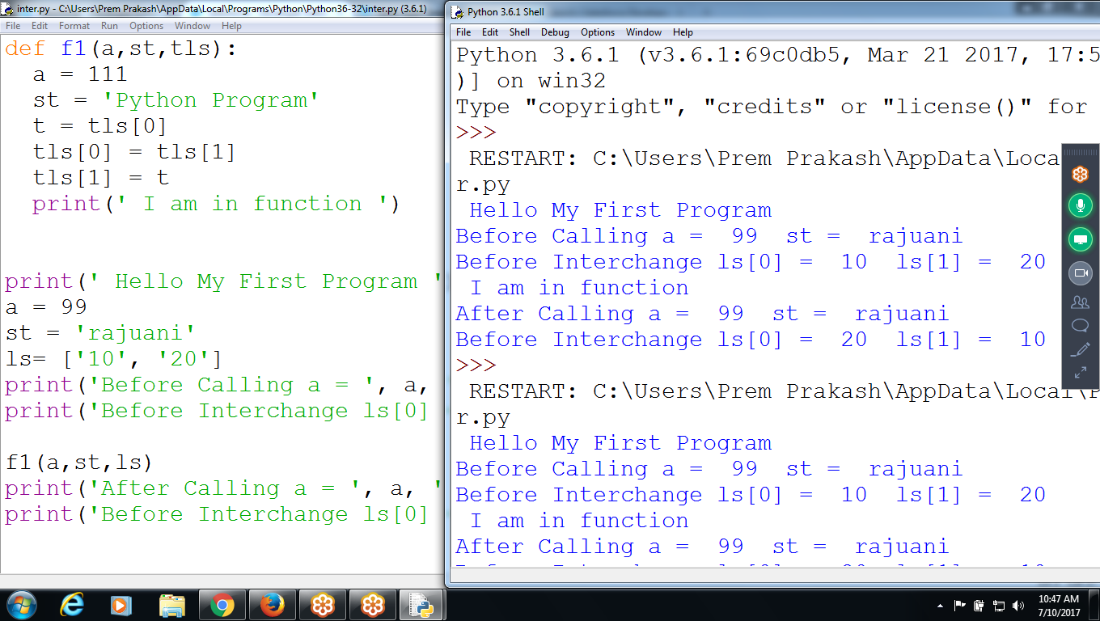

Outside the function:: values are erased in Function

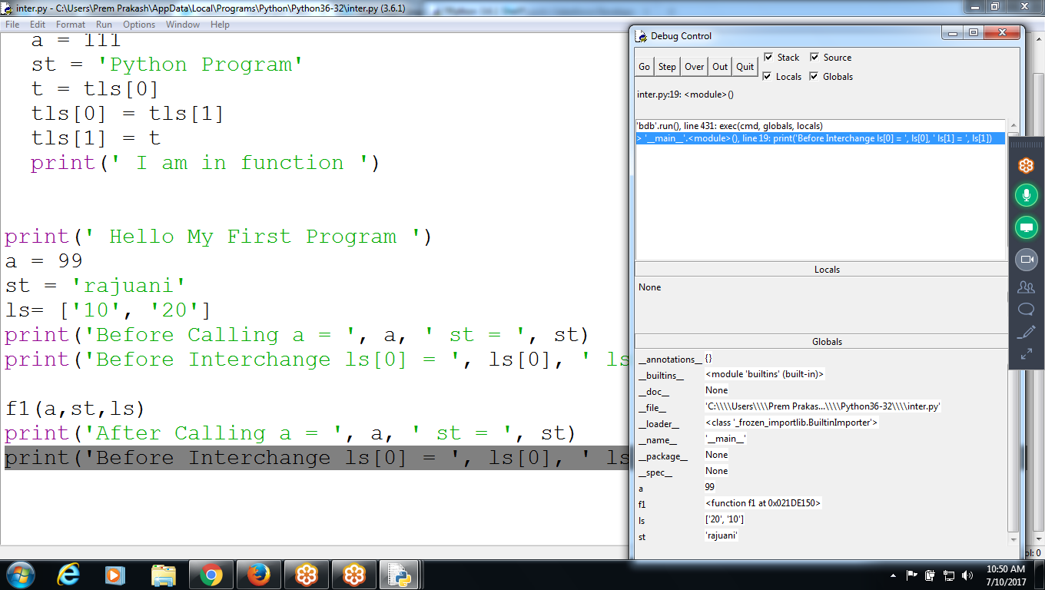

MEMORY Management of Variables

A value of type integer

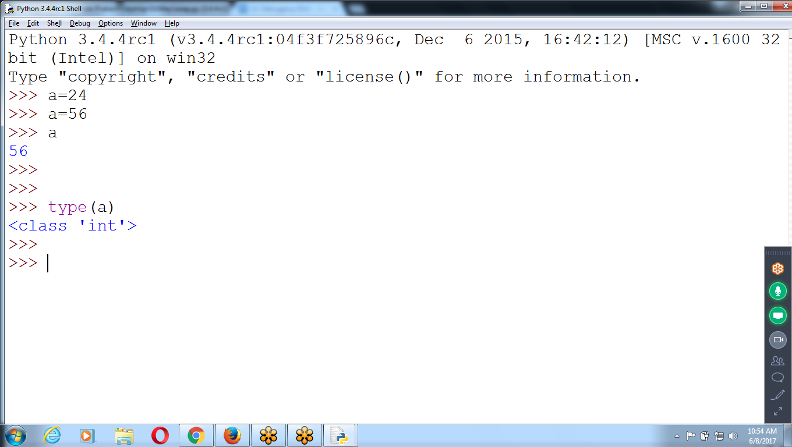

3 Windows opened : Program, Shell, Debug Opened : Click Execute

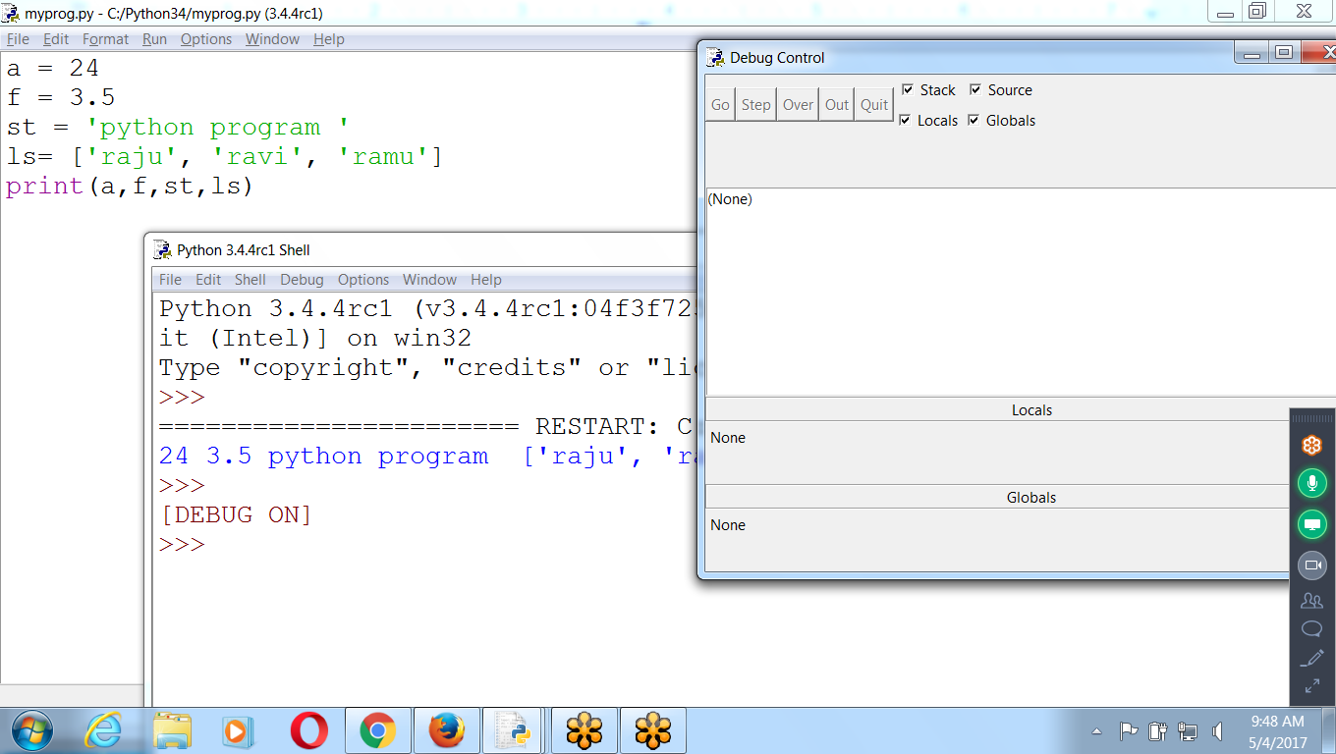

Run (F5)

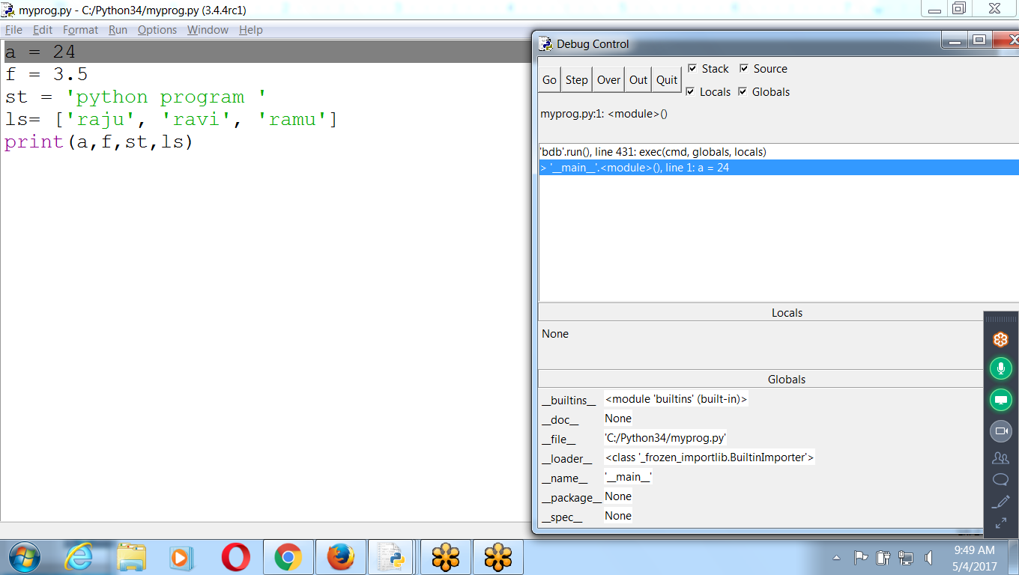

The program will stay paused until press one of the five buttons in the Debug Control window: Go, Step, Over, Out, or Quit.

## **Go**

* Clicking the Go button will cause the program to execute normally until it terminates or reaches a *breakpoint*.
* If debugging is done and want the program to continue normally, click the **Go** button.

Run - execute - CLICK “GO” in debugger

Result : Normal Execution Program

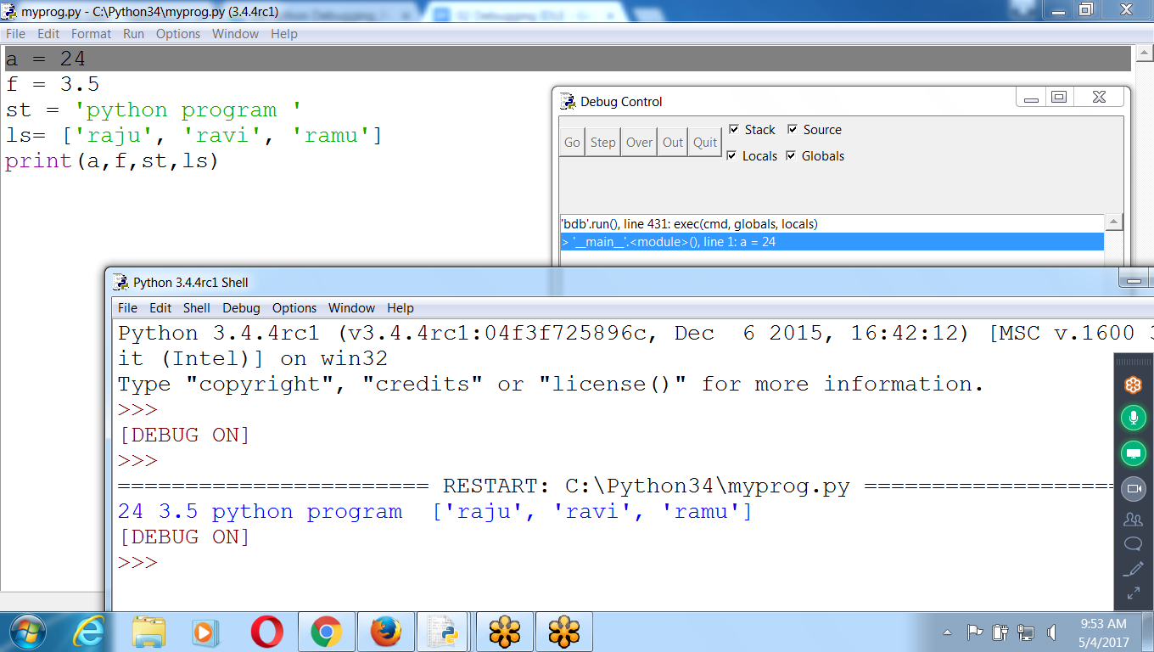

## 

## 

## **2) Step (Jumps into the function)**

* Clicking the Step button will cause the debugger to execute the next line of code and then pause again.
* The Debug Control window’s list of global and local variables will be updated if their values change.
* If the next line of code **is a function call,** the debugger will “step into” that function and **jump to the first line of code** of that function.

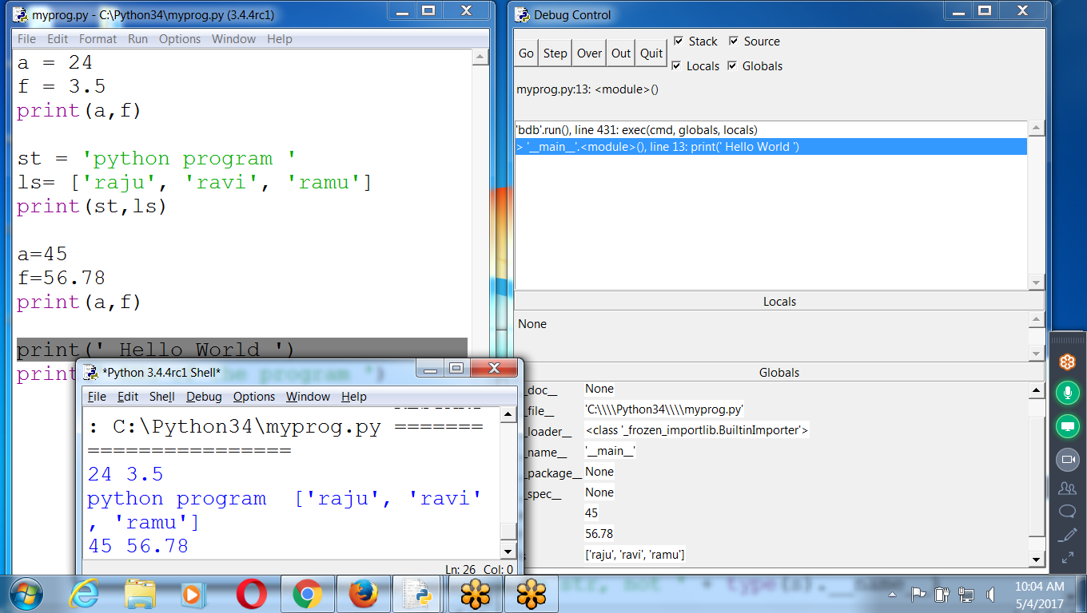

OUt: Comes out of the function

Quit: It stops current execution

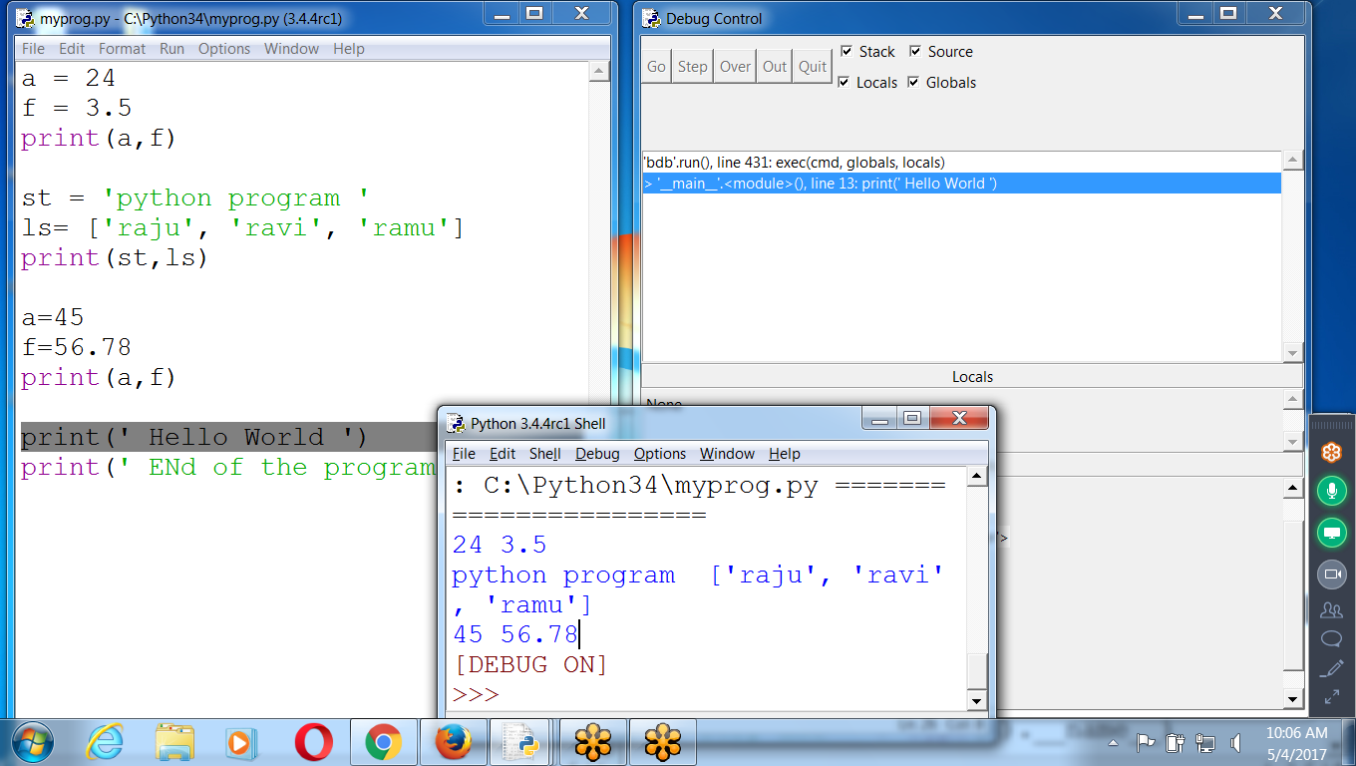

## **3)Over (Don’t enter into function)**

* Clicking the Over button will execute the next line of code, similar to the Step button. However, if the next line of code is a function call, the Over button will “step over” the code in the function.
* The **function’s code will be executed** and the debugger will pause as soon as the function call returns.
* For example, if the next line of code is a **print()** call, don’t really care about code inside the built-in print() function; just want the string you pass it printed to the screen. For this reason, using the **Over button** is more common than the Step button.

## **Out ( Out of the function)**

* Clicking the Out button will cause the debugger to execute lines of code at full speed until **it returns from the current function**.
* If you have stepped into a function call with the Step button and now simply want to keep executing instructions until you get back out, click the **Out** button to “step out” of the current function call.

## **Quit ( Quit from the program)**

* To stop debugging entirely and **not to continue executing** the rest of the program, click the **Quit** button.
* The Quit button will immediately terminate the program. If you want to run your program normally again, select **Debug**▸**Debugger** again to disable the debugger.

**Testing 2 : Using Functions with Return values**

def f1(a,st):

print(' I am in f1 ')

a = 48

st = 'raju'

b = 45.4

print(' End of the f1 ')

r = a + 12

return r

a = 24

st = 'python'

print(a,st)

rt = f1(a,st)

print(' Return value = ', rt)

print(a,st)

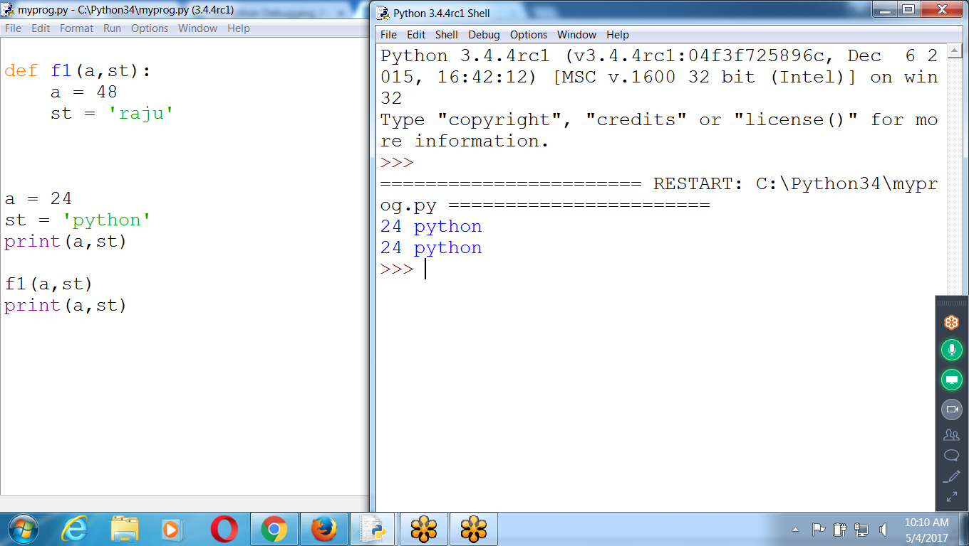

**Testing for Local and Global Variables**

Control is in F1() local variables :: a: 48, st :raju

Global: a =24, st :python

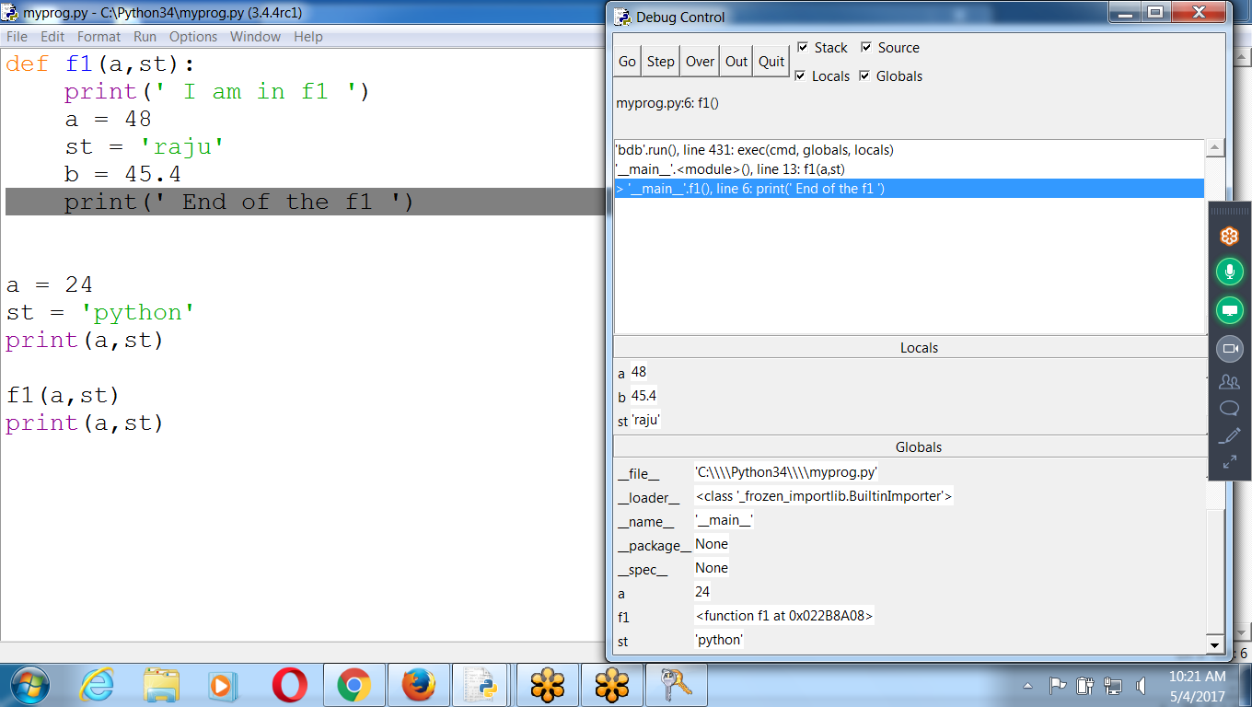

Once control moves out of the function : local values are erased

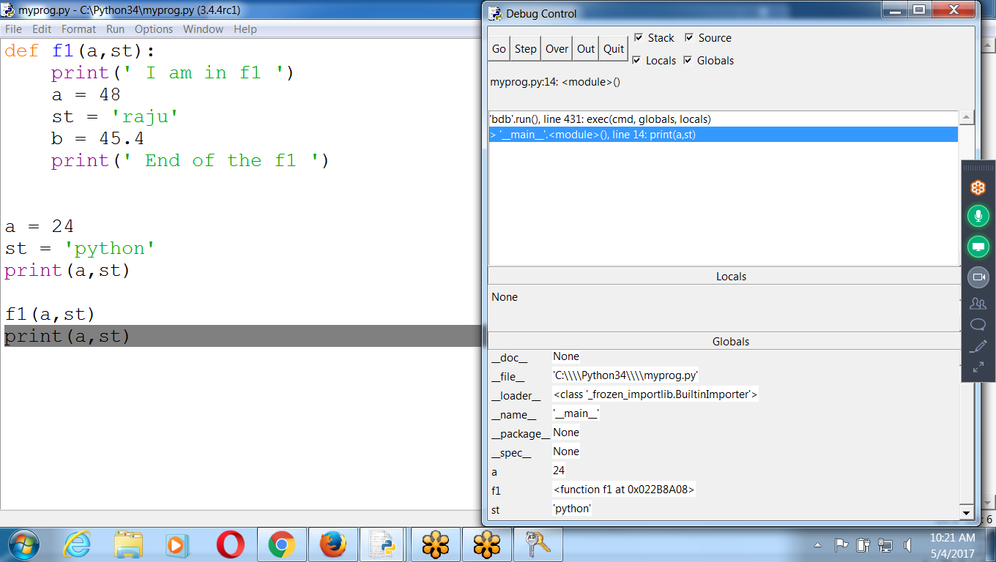

3) On Returning value from a function

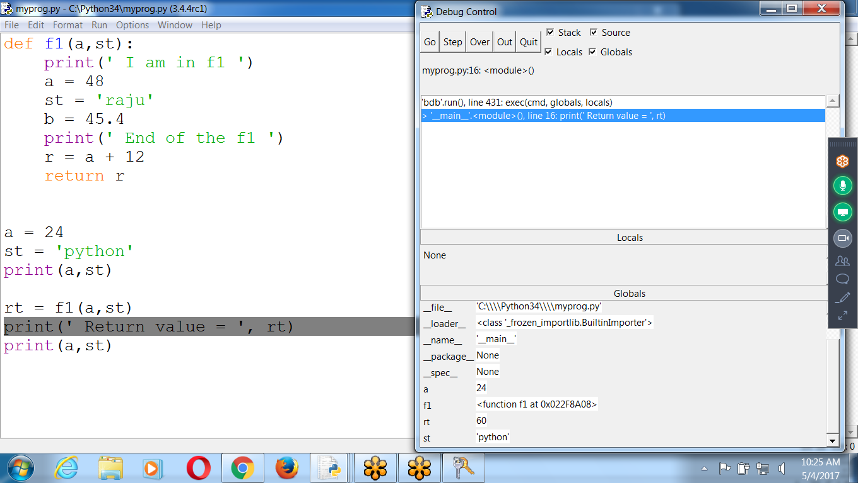

def f1(a,st):

print(' I am in f1 ')

a = 48

st = 'raju'

b = 45.4

print(' End of the f1 ')

r = a + 12

return r

a = 24

st = 'python'

print(a,st)

rt = f1(a,st)

print(' Return value = ', rt)

print(a,st)

DEBUGGER is OFf , Normal Execution like “RUN”

Executes All statements Directly

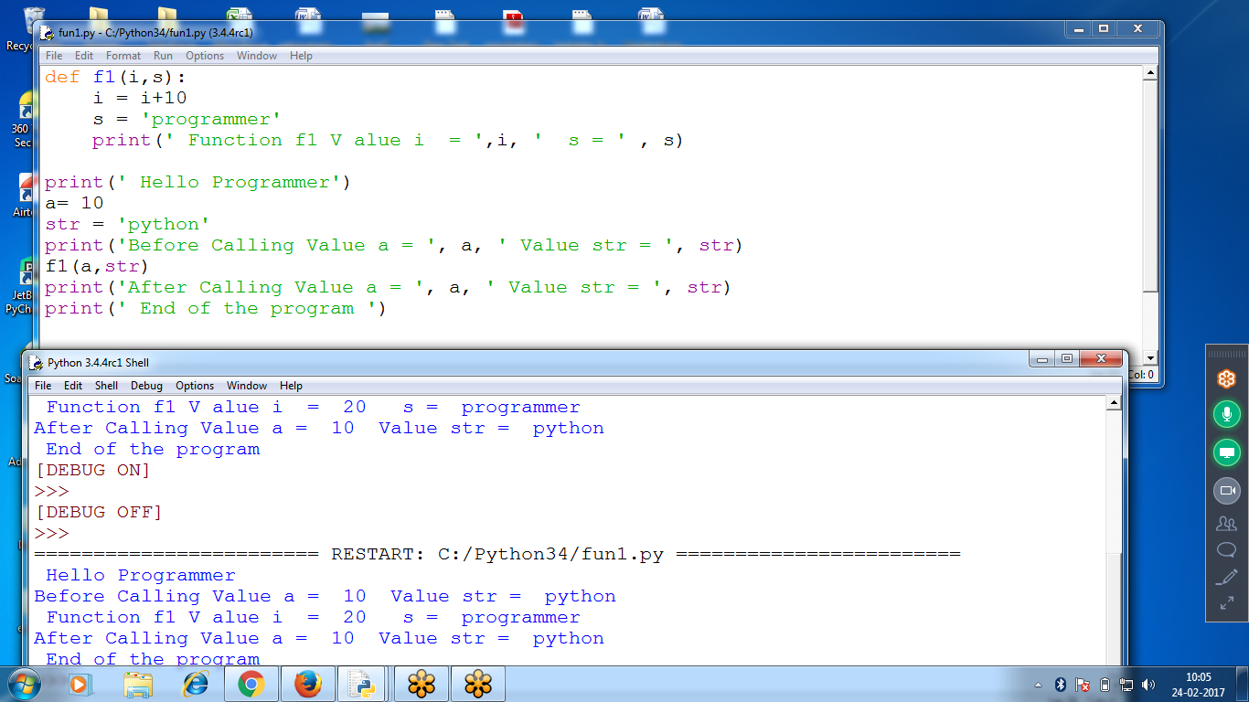

def f1(a,st):

print(' I am in f1 ')

a = 48

st = 'raju'

b = 45.4

print(' End of the f1 ')

a = 24

st = 'python'

print(a,st)

f1(a,st)

print(a,st)

Click “GO” :: Normal Execution

Local and Global variables inside FUNCTION F1

F1 Local variables :: i and s

Global Variables : a and str

Displaying Local variables i and s

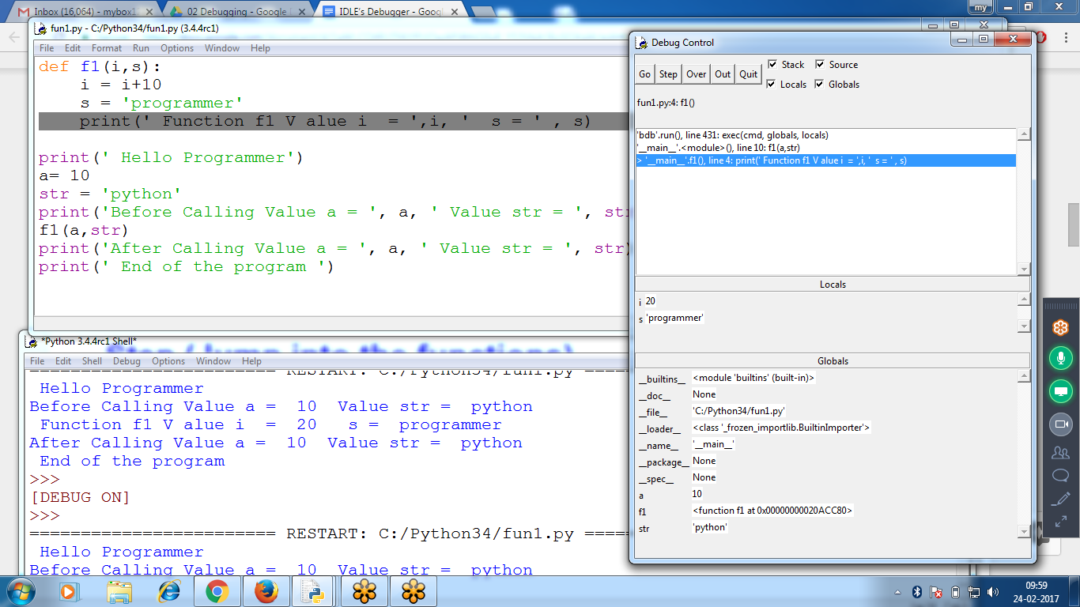

Outside Function f1: don’t find i ans s variables

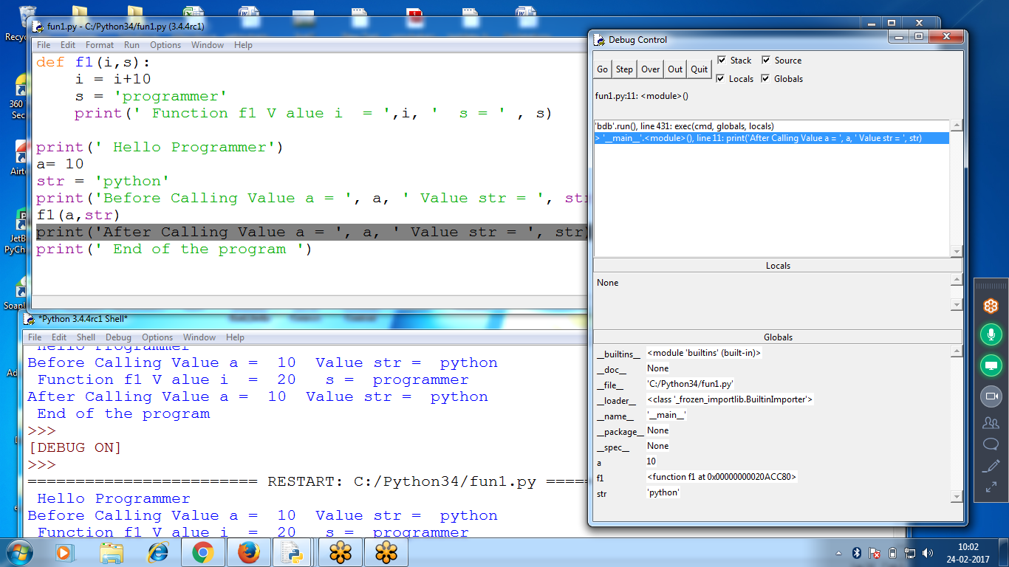

Inside Standard Function print():::

click “OUT” (to come out from the function)

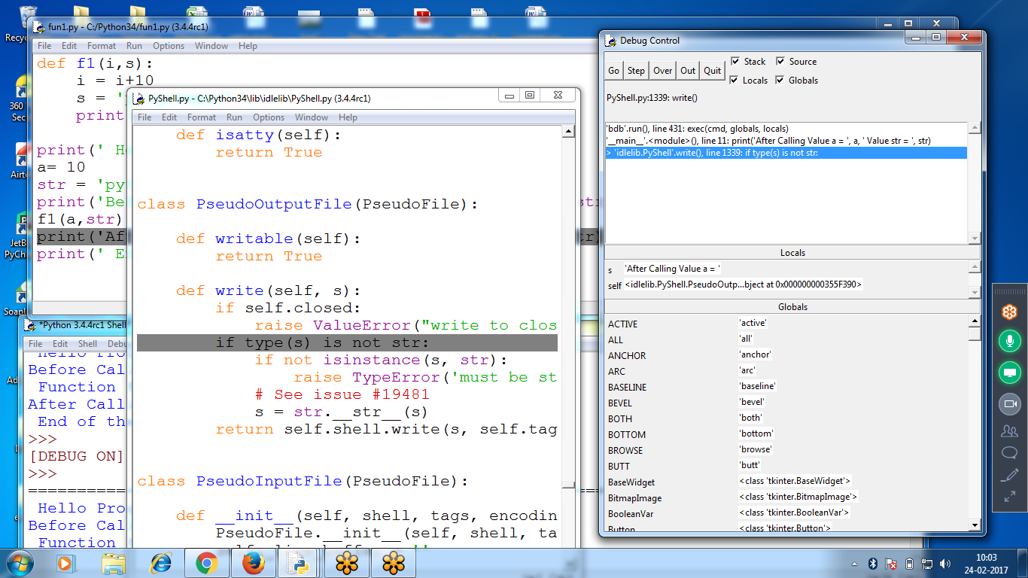

Checking For SCope ::: Global and Local

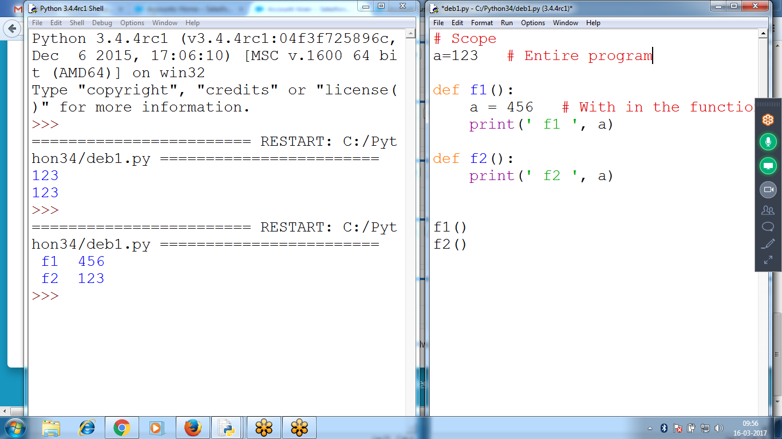

a=123 is Global

a=456 is Local

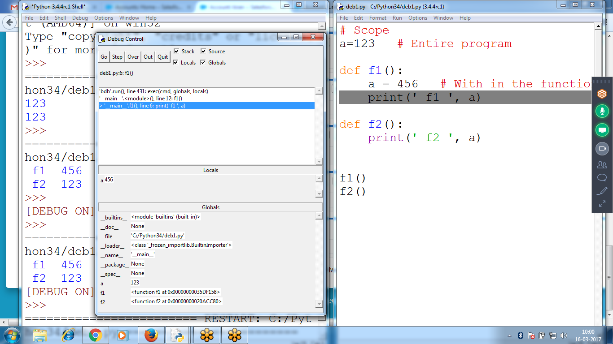

Outside the function, can access Global variables, local can not access

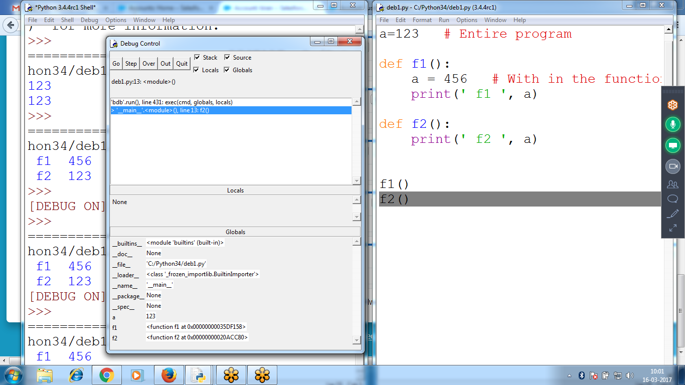

Program 2 :: Debugging using Functions

In print itself having fm(), fd()

On selection of “step”, enters into fm() first line code

def fm(a,b):

print('value a = ',a)

print('Value b = ',)

c = a *b

return c

def f1():

a = int(input('Enter value for a '))

b = int(input('Enter value for b '))

**print(' Mul a, b = ', fm(a,b))**

print(' Program strats ')

f1()

print(' End of the program ')

Control is at print(fm() ) and calling fm() inside print

On selection of “step” enters to fm() of first line

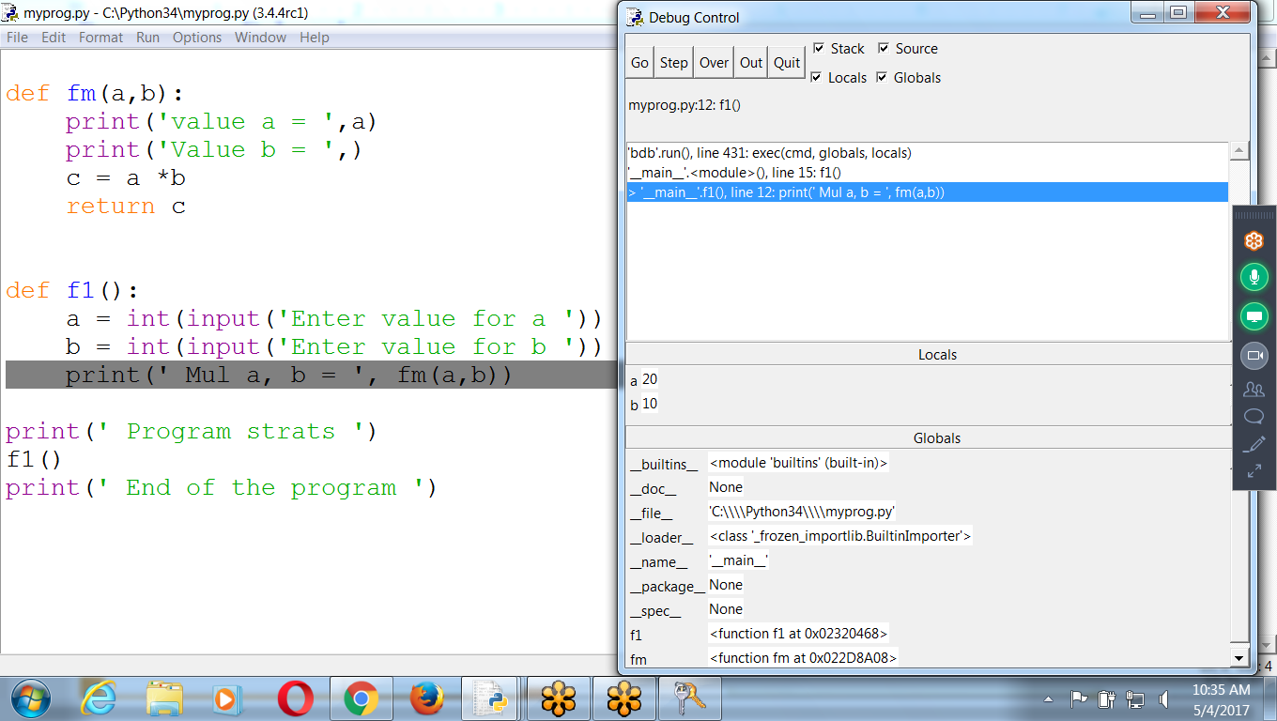

****************************************************************************************************************************************************

## **Breakpoints**

A *breakpoint* can be set on a specific line of code and forces the debugger to pause whenever the program execution reaches that line.

Without Breakpoint, Click GO, completes execution

Set Breakpoint stops execution

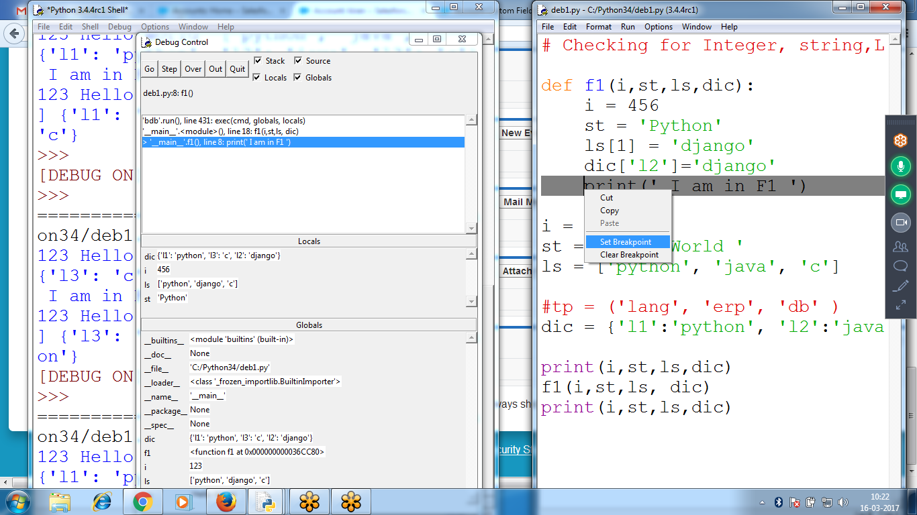

Set Breakpoint, click GO

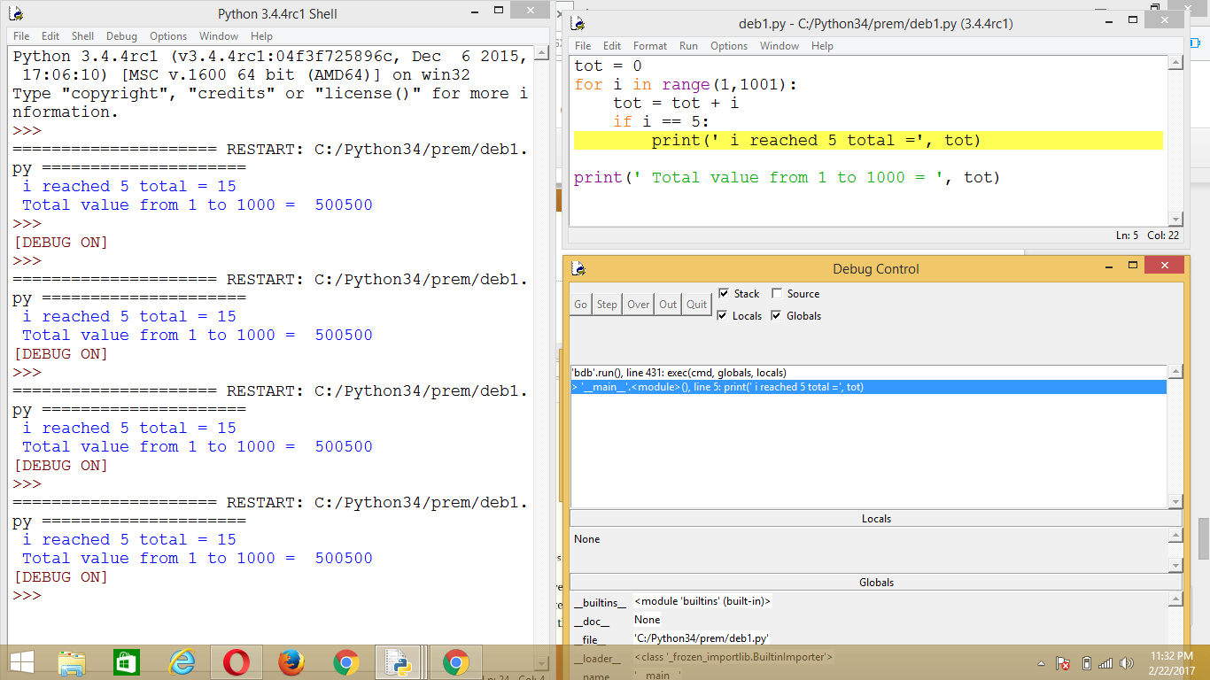

# Sum of the values 1 to 1000

tot =0

for i in range(1001):

if( i == 5):

**print(' Total value at = ',i, ' = ', tot)**

tot = tot + i

print(' Total value = ', tot)

Checking with integer, string, list and tuple

List variable are modified

Integer, float, string and tuple are not modifing

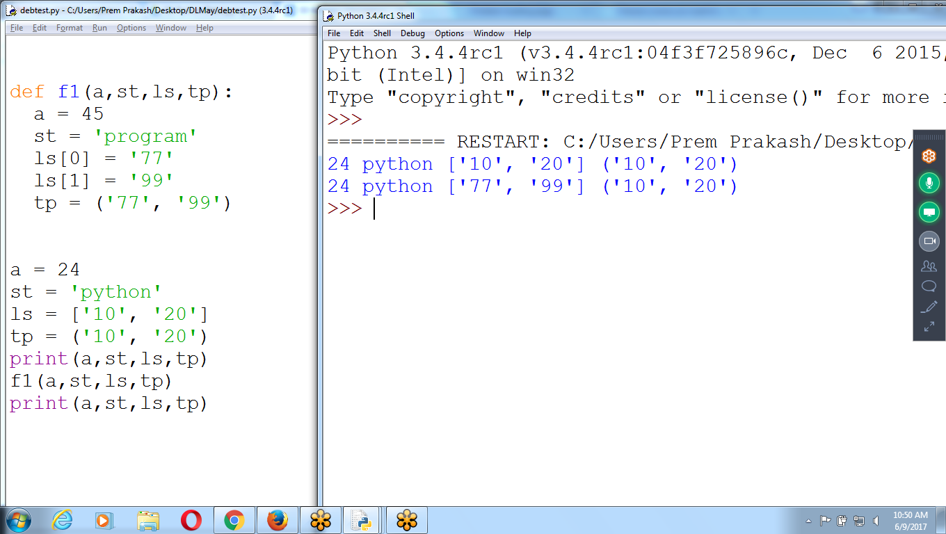

def f1(a,st,ls,tp):

a = 45

st = 'program'

ls[0] = '77'

ls[1] = '99'

tp = ('77', '99')

a = 24

st = 'python'

ls = ['10', '20']

tp = ('10', '20')

print(a,st,ls,tp)

f1(a,st,ls,tp)

print(a,st,ls,tp)

Interchange to Two values

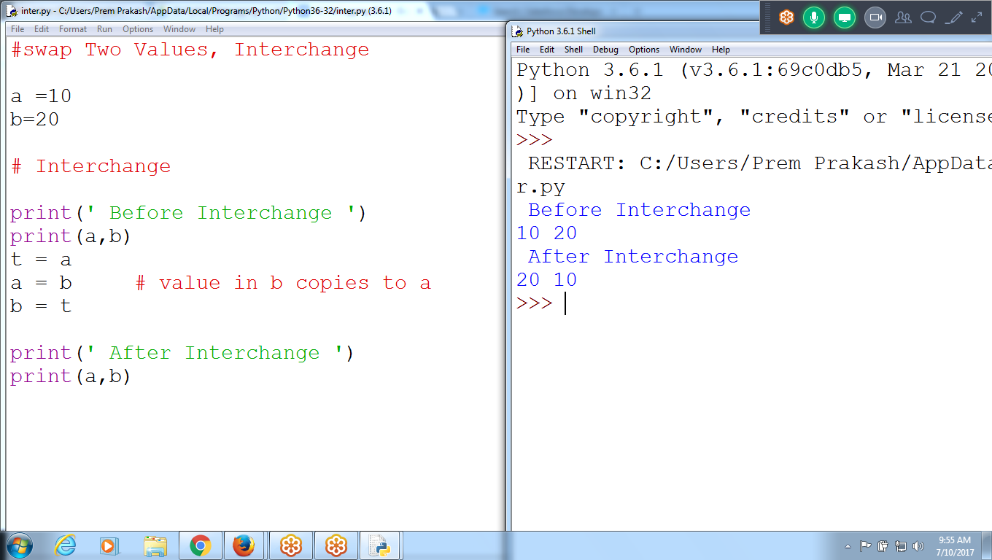

Single Line Statement, to interchange two variables

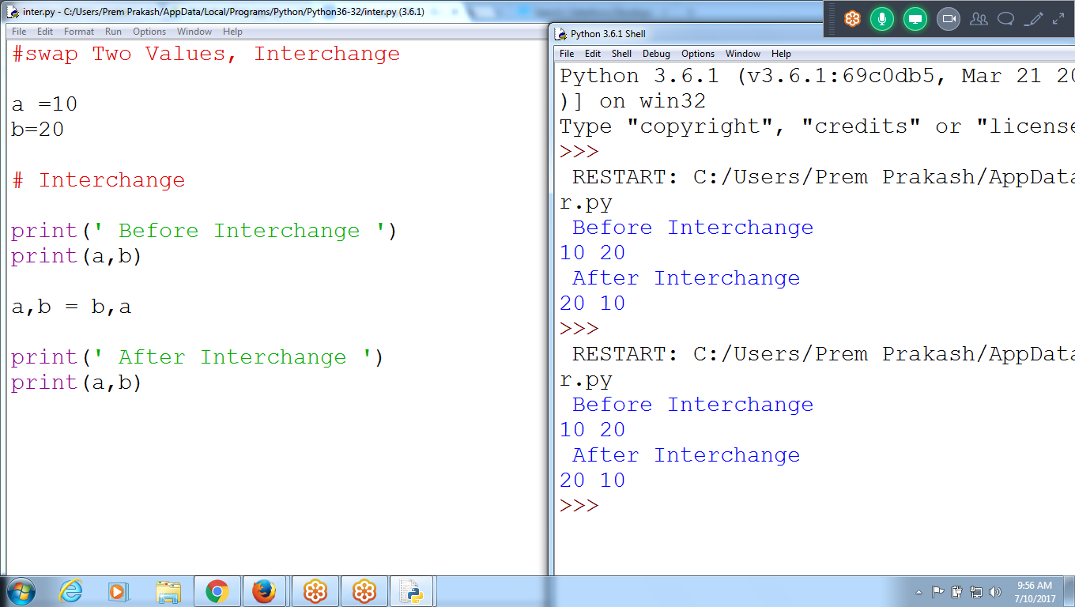

INterchange 4 values

a,b,c,d = d,c,b,a

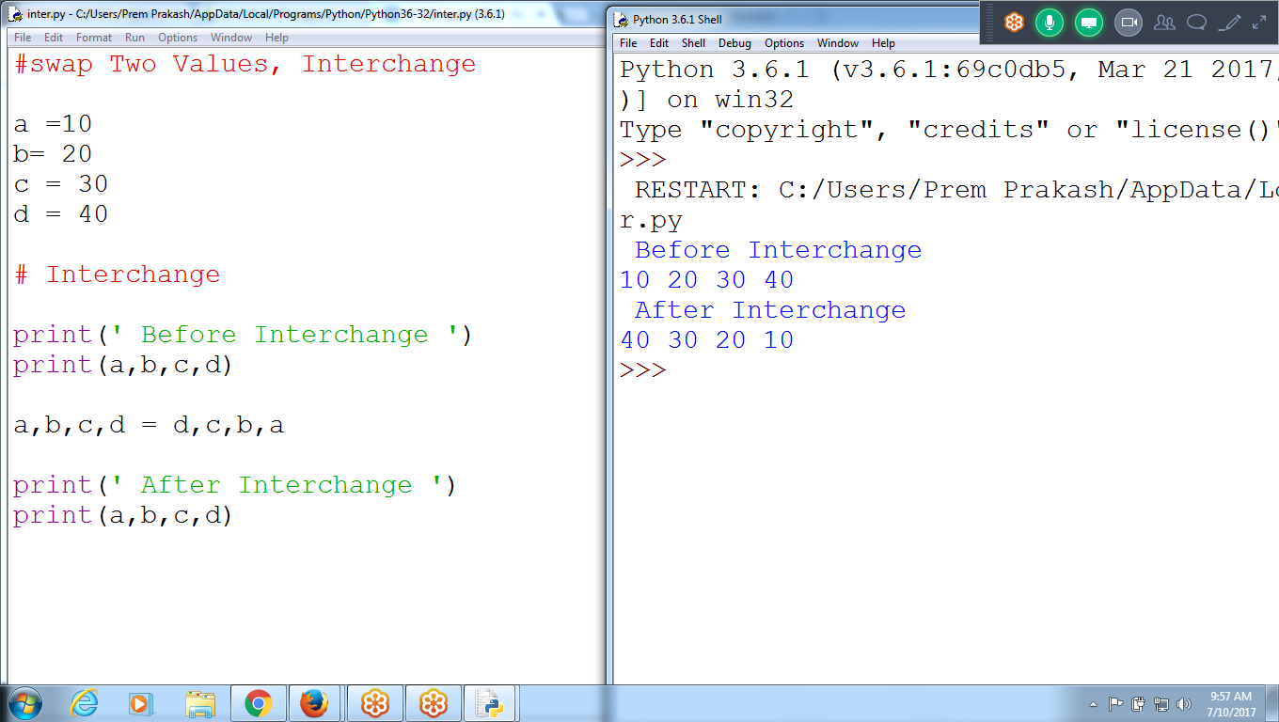

#swap Two Values, Interchange

a =10

b= 20

c = 30

d = 40

# Interchange

print(' Before Interchange ')

print(a,b,c,d)

a,b,c,d = d,c,b,a

print(' After Interchange ')

print(a,b,c,d)

INterchange of two values using Functions

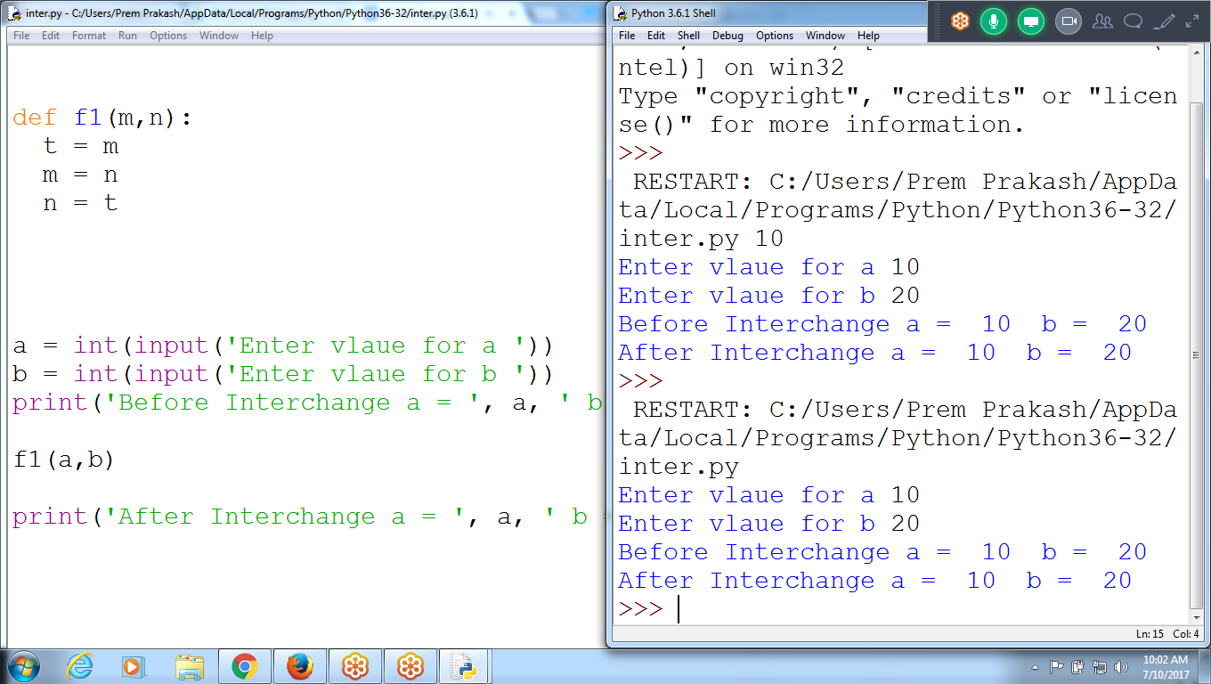

Result: Values not interchanged

Swapping of two values - click (F5)

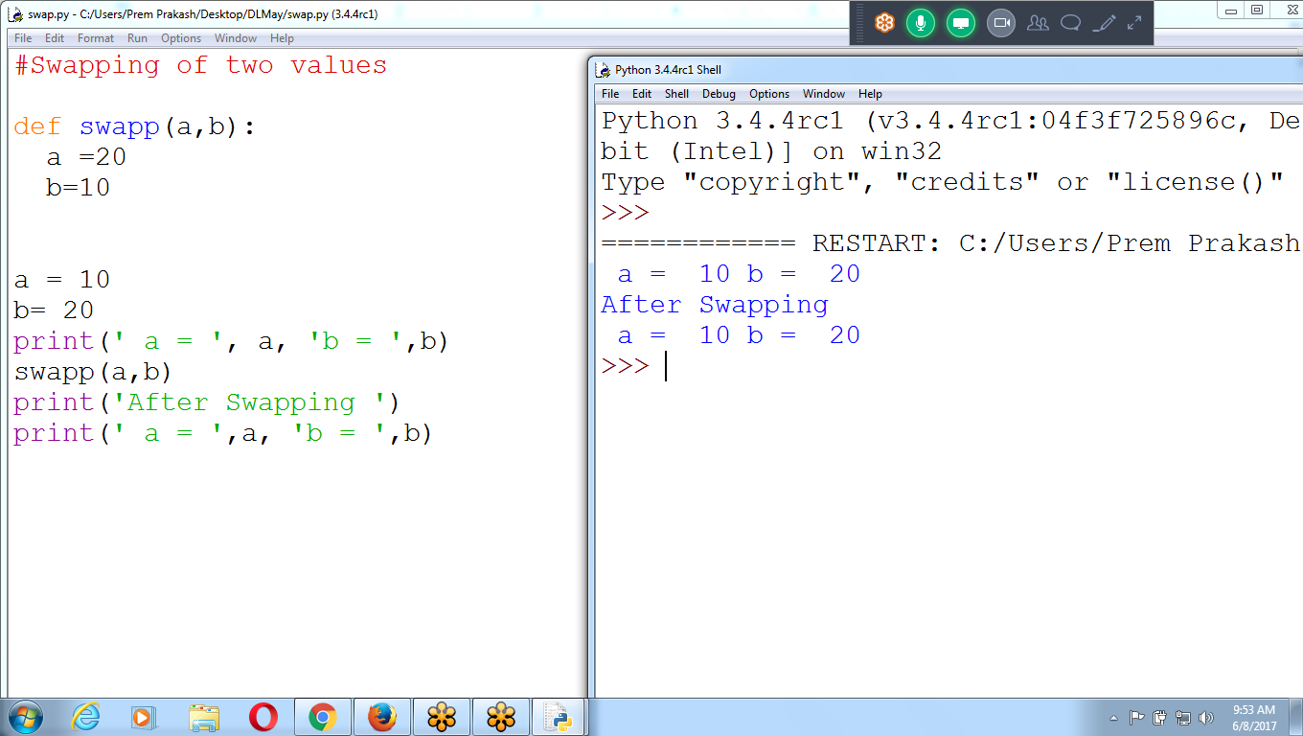

#Swapping of two values

def swapp(a,b):

a =20

b=10

a = 10

b= 20

print(' a = ', a, 'b = ',b)

swapp(a,b)

print('After Swapping ')

print(' a = ',a, 'b = ',b)